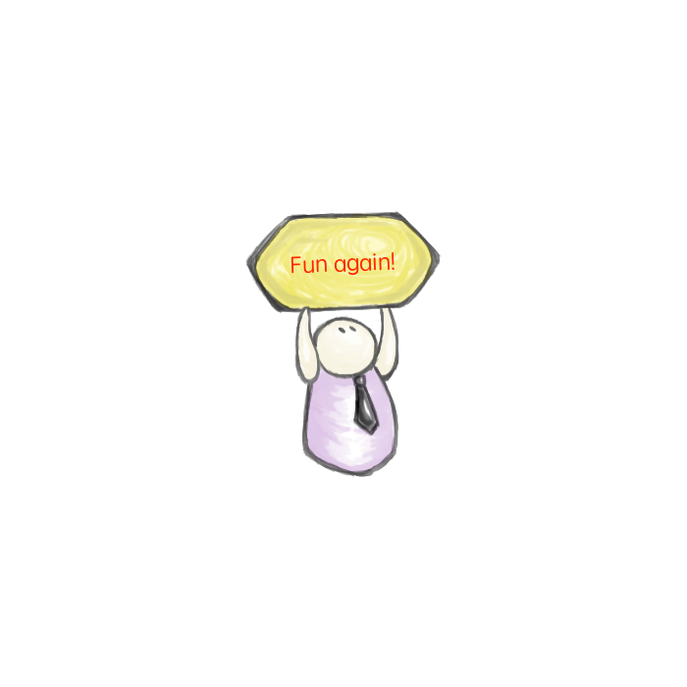


Cir. Ref: A(25) xxx

TO ALL MEMBERS 24 July 2025

HKSOA
Table Tennis Tournament
and Fun Days
+ Celebration Dinner

Fun again! We will host the 3rd Table Tennis Tournament and Fun Days on 15-16 October 2025 (Wednesday and Thursday) in the Sports Hall of the South China Athletic Association. The awards presentation ceremony, scheduled for the evening of 16 October (Thursday), will be followed by a “Celebration Dinner” at a restaurant in the Association, for more fun and networking.

Competition categories

- Individual - Men’s Singles (Youth) (aged under 40)
- Individual - Men’s Singles (Master) (aged 40 to 59)
- Individual - Men’s Singles (Senior) (aged 60 or above)
- Individual - Women’s Singles (no age limits)
- Individual – Men’s Doubles (no age limits)
- Individual – Women’s Doubles (no age limits)
- Group* – Men’s Doubles (no age limits), Women’s Doubles (no age limits) and Mixed Doubles (no age limits)
- Friendship competition – by invitation only

*Every group in the Group competition category shall nominate only players who do not take part in the Individual competition categories.

Competition rules

For all matches, the winner is the best of three games. A game is won by being the first player to win 11 points, and be at least two points ahead of the opponent. If both players have won 10 points, then the first player to get a two-point lead wins the game.

Prizes and awards

Medals will be awarded to the Individual category winners. Trophies will be awarded to the winning member companies of the Group category.

Fees and charges

The competition events are free-of-charge.

All the players and their cheering teams would be welcome to the Celebration Dinner held immediately after the award presentation ceremony. For the players, the dinner will be free-of-charge for all the quarter-finalists, semi-finalists and finalists. For the cheering teams, the dinner will be free-of-charge for six representatives each from the best four cheering teams. For other players and cheering team members, the charge will be $300/head. (Dinner tickets can be purchased at the reception counter in the Sports Hall prior to the dinner.)

Programme rundown (tentative, subject to change)

15 October 2025 (Wednesday)

- Fun day for all - all are welcome to join, for fun and practice, from 2pm to 6pm.

- Preliminary rounds for Group categories, from 3pm to 6pm.

- Preliminary rounds for Individual categories, from 6pm to 9pm.

16 October 2025 (Thursday)

- Fun day for all - all are welcome to join, for fun and practice, from 2 pm to 5pm.

- Quarter-final, Semi-final and Final rounds for Individual categories, from 2pm to 6pm

- Quarter-final, Semi-final and Final rounds for Group categories, from 2pm to 6pm

- Friendship competitions, from 5pm to 6pm

- Awards presentation ceremony at 6pm, followed by the Celebration Dinner.

Please complete and return the attached reply form by 10 September 2025 to enable us to assess attendance.

Don’t miss the fun!

To: The Hong Kong Shipowners Association

Fax: 2529-8246 or Email : hksoa@hksoa.org

Association Table Tennis Tournament and Fun Days, 15-16 October 2025
3/F Sports Hall, South China Athletic Association, Caroline Hill Road, Causeway Bay, Hong Kong

The following players will join the Individual categories.

(Please tick the right boxes. Every member company shall nominate not more than 10 players, in total, for all the six categories)

 | Name | Men’s Singles (Youth) | Men’s Singles (Master) | Men’s Singles (Senior) | Women’s Singles | Men’s Doubles | Women’s Doubles
1
2
3
4
5
6
7
8
9
10
11*
12*
13*
14*
15*
16*
17*
18*
19*
20*
21*
22*
23*
24*
25*
26*
27*
28*
29*
30*

＊Only for event partners/sponsors, who may nominate up to 20 players or 30 players, in total, to join the Individual categories.

The following players will join the Group categories.

There are three matches for each team in each round: Men’s Doubles (no age limits), Women’s Doubles (no age limits) and Mixed Doubles (no age limits). Each team may decide, on the spot, on the representatives to play in the different matches and rounds.

Team A |  | Team B* |  | Team C*
Mr./Ms. |  | Mr./Ms. |  | Mr./Ms.
Mr./Ms. |  | Mr./Ms. |  | Mr./Ms.
Mr./Ms. |  | Mr./Ms. |  | Mr./Ms.
Mr./Ms. |  | Mr./Ms. |  | Mr./Ms.
Mr./Ms. |  | Mr./Ms. |  | Mr./Ms.
Mr./Ms. |  | Mr./Ms. |  | Mr./Ms.
Mr./Ms. |  | Mr./Ms. |  | Mr./Ms.
Mr./Ms. |  | Mr./Ms. |  | Mr./Ms.
Mr./Ms. |  | Mr./Ms. |  | Mr./Ms.
Mr./Ms. |  | Mr./Ms. |  | Mr./Ms.

＊Only for event partners/sponsors, who may nominate up to two teams or three teams to take part in Group categories.

Company Name | :
Email | :
Contact Person | : |  | Tel | :

Notes:

- Please complete and return the enrolment form by 10 September 2025.

- If you would like to change the names of players after submission of this enrolment form, please inform the Association secretariat at hksoa@hksoa.org not later than 30 September 2025.

- The Association secretariat will draw lots on the game order and make announcements about the logistics in due course.

